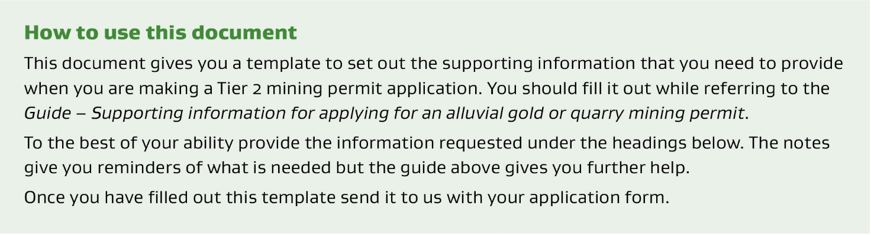

1 | Objective of proposed operation
What is the objective of the proposed operation?

2 | Availability of land area and minerals
Is the land available? Are the minerals Crown owned? If the application is for minerals other than gold or silver,
is a Land and Mineral Status (LMS) report provided?

3 | Application area
State the area of the permit being applied for. Generally, the permit area of a Tier 2 mining permit will not be greater than 200 ha.

4 | Duration
How long do you want the permit? Typically the duration of a Tier 2 mining permit will not be longer
than 10 years.

5 | The work programme
Outline a work programme for the permit that covers exactly what you propose to do on the permit. You need to provide sufficient detail to demonstrate consistency with good industry practice.
On the basis of your description here, a minimum work programme will be agreed with NZP&M. This is usually based on key milestones (such as the commencement of mining) and ongoing commitments (such as maintaining a minimum mining rate).
Your application should state what you consider to be realistic minimum work programme obligations. Proposed production rates in particular should be kept realistic. NZP&M will monitor compliance against the agreed minimum work programme.

6 | Geology, occurrence of minerals in the permit area and the applicant’s knowledge
Provide a description of the regional/local geology and how it relates to the resource/deposit you will mine.

7 | Estimates of total in-ground and mineable mineral resources
Include an estimate of both total in-ground resources and the mineable mineral resource. Provide information on how the estimate was determined and the outcome of that estimate. For example:
- Nature, quality, values and location of informing data.
- Dimensions of the resource.
- A table showing tonnes/volume, grade (e.g. for gold) and metal (e.g. troy ounces for gold).
- A map of the resource area within the application area.

8 | Applicant’s mining feasibility studies and project economics
i) Feasibility studies
It is unlikely a full feasibility study will have been made. However, you will need to provide information on the mining method, mine plan, schedule and equipment to be used. This should be in line with the work programme above but reflect the expected mining rate rather than the minimum.
ii) Project economics
Provide information about the annual inputs, capital and operating costs broken down into suitable time periods (for example weeks) that demonstrate that you will make a profit from your proposed work programme. You also need to indicate the basis for the information, such as whether it is an assumption, quote or industry standard. The information may cover:
- plant and equipment capital and operating costs (for example, lease costs, maintenance, fuel)
- personnel costs (for example, wages)
- other costs (such as land access, consenting, stripping, rehabilitation)
- production start date and rate
- projected metal recovery and value, including value of mineral by unit (for example, $/oz gold) and
- the expected margin.

9 | Consistency of proposed mining operations with good industry practice
Make a statement supported by reasoning and an explanation about how the proposed mining operation is in line with industry practice. For example, is what you are proposing in line with accepted general practice for mining the mineral in question?

10 | Consistency of proposed mining operations with good industry practice
i) Financial capability
Demonstrate you have the financial capability to meet the capital and operating costs of the operation for example, through bank statements, company accounts etc. Making a statement that you have the capability is not sufficient, you also need to provide information to support the statement you are making.
ii) Technical capability
Describe the technical experience and any qualifications the proposed ‘operator’ has, which demonstrate how the operator has the capability to manage the day-to-day operation in line with the work programme.
If you plan to use contractors, provide details of the contractor’s experience and their capability to manage such contracts.

11 | Compliance history
Discuss and ‘front foot’ any compliance issues you are aware of regarding meeting work programmes, reporting obligations or payment of fees or royalties of any previous or related mineral permits (including overseas).

